Name of Laboratory : Electrical Workshop

|  |  |
| --- | --- |
| Lab Subject Code | : EEE1003 |
| Name of School | : SELECT |
|  |  |

**WIRING CIRCUIT FOR A SINGLE LAMP AND A FAN WITH REGULATOR**

**Ex. No. : 6** **Date** **: 22/11/2021**

**Aim**

To understand the internal wiring of a switch box to control a lamp, fan and an external gadget connected to a 5-pin socket.

**Materials Required**

|  |  |  |  |
| --- | --- | --- | --- |
| **S. No.** | **Name of the apparatus** | **Range / Type** | **Quantity** |
|  |  |  |  |
| 1 | Incandescent Lamp | 230 V, 25 W | 1 Nos. |
|  |  |  |  |
| 2 | Lamp holder | 230 V, Level | 3 Nos. |
|  |  |  |  |
| 3 | Ceiling fan | 230V, 60W | 1 No. |
|  |  |  |  |
| 4 | Switch Box | 12” x 4” | 4 Nos. |
|  |  |  |  |
| 5 | Fan regulator | 230V | 1 No. |
|  |  |  |  |
| 6 | 1 way switch | 230 V, 5 A | 3 Nos. |
|  |  |  |  |
| 7 | P. V. C. casing capping | ¼” | As required |
|  |  |  |  |
| 8 | Wooden Board | 4’ x 3.5‘ | 1 No. |
|  |  |  |  |
| 9 | Ceiling rose | 230 V | 1 Nos. |
|  |  |  |  |
| 10 | Wires | 1 sq. mm” | As required |
|  |  |  |  |

**Tools Required**

Screw driver, Wire stripper, Hacksaw, combination plier, drilling machine, electrician knife

**Procedure**

1. Collect the materials required for this experiment.
2. Draw the layout of the given circuit diagram on the work board.
3. Fix the switches, regulator, indicator and 5-pin socket by using necessary tools in the switch board front panel.
4. Do the internal connections using wires of required size as per the circuit diagram.
5. Test the circuit and note down the observations.

**Precautions**

1. Energize the circuit with the presence of Lab instructor / Faculty.
2. No part of a live circuit should be touched by the bare hand.
3. Keep the body, or any part of it, out of the circuit.
4. Keep the work area and workbench clear of items not used in the experiment.
5. When disassembling a circuit, first remove the source of power.

Name of Laboratory : Electrical Workshop

|  |  |
| --- | --- |
| Lab Subject Code | : EEE1003 |
| Name of School | : SELECT |
|  |  |

**Fuse Rating Calculations**

Total Power drawn by the circuit = 60+40+100 watts Voltage of the circuit = 230 volts

P = V I COS Ø

P = V x I x 1 (Assuming COS Ø = 0.8 for resistive load) Current in the circuit (I) = power (P) / (Voltage (V) x COS Ø)

= 200 W / (230 V x 0.8) = 1.0869 A.

Fuse rating of the circuit= rounding off the current to the nearest 5 = 5A (Normally fuses are available in the ratings of 5A, 10A and etc.)

**Wiring Diagram – Switch Board (internal)**

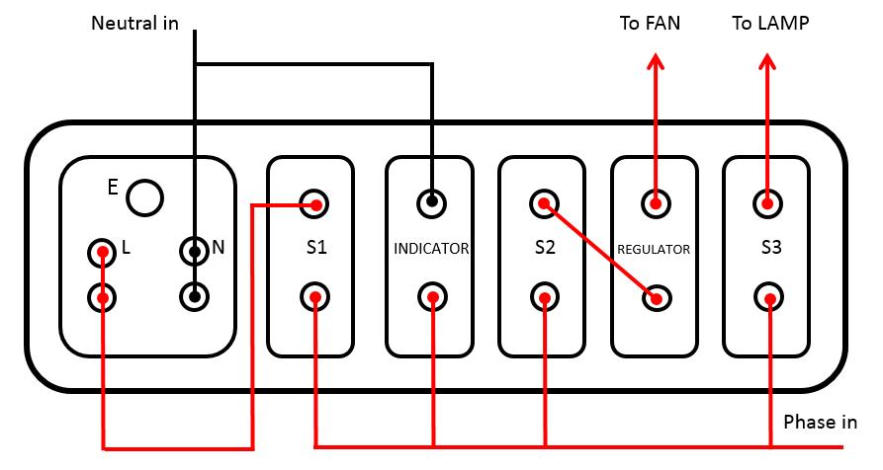

Name of Laboratory : Electrical Workshop

|  |  |
| --- | --- |
| Lab Subject Code | : EEE1003 |
| Name of School | : SELECT |
|  |  |
| **Circuit Diagram** |  |

**Observation**

|  |  |  |  |  |  |  |  |  |  |  |  |  |  |  |  |  |
| --- | --- | --- | --- | --- | --- | --- | --- | --- | --- | --- | --- | --- | --- | --- | --- | --- |
|  |  |  | **Expected conditions** | | | |  |  |  | **Observed conditions** | | | | | |  |
| **Condition No** |  |  |  |  |  |  |  |  |  |  |  |  |  |  |  |  |
| S1 | S2 | S3 | Indi | Ext. |  | Fan | Lamp | S1 | S2 | S3 | Indi | Ext. | Fan | Lamp |  |
|  |  |  |
|  | cator | Load |  | cator | Load |  |
|  |  |  |  |  |  |  |  |  |  |  |  |  |
| 1 | ON | OFF | OFF | ON | ON |  | OFF | OFF | **ON** | **OFF** | **OFF** | **ON** | **ON** | OFF | OFF |  |
|  |  |  |  |  |  |  |  |  |  |  |  |  |  |  |  |  |
| 2 | OFF | ON | OFF | ON | OFF |  | ON | OFF | **OFF** | **ON** | **OFF** | **ON** | OFF | **ON** | OFF |  |
|  |  |  |  |  |  |  |  |  |  |  |  |  |  |  |  |  |
| 3 | OFF | OFF | ON | ON | OFF |  | OFF | ON | **OFF** | **OFF** | **ON** | **ON** | OFF | OFF | **ON** |  |
|  |  |  |  |  |  |  |  |  |  |  |  |  |  |  |  |  |
| 4 | ON | ON | OFF | ON | ON |  | ON | OFF | **ON** | **ON** | **OFF** | **ON** | **ON** | **ON** | OFF |  |
|  |  |  |  |  |  |  |  |  |  |  |  |  |  |  |  |  |
| 5 | OFF | ON | ON | ON | OFF |  | ON | ON | **OFF** | **ON** | **ON** | **ON** | OFF | **ON** | **ON** |  |
|  |  |  |  |  |  |  |  |  |  |  |  |  |  |  |  |  |
| 6 | ON | OFF | ON | ON | ON |  | OFF | ON | **ON** | **OFF** | **ON** | **ON** | **ON** | OFF | ON |  |
|  |  |  |  |  |  |  |  |  |  |  |  |  |  |  |  |  |
| 7 | ON | ON | ON | ON | ON |  | ON | ON | **ON** | **ON** | **ON** | **ON** | **ON** | **ON** | **ON** |  |
|  |  |  |  |  |  |  |  |  |  |  |  |  |  |  |  |  |

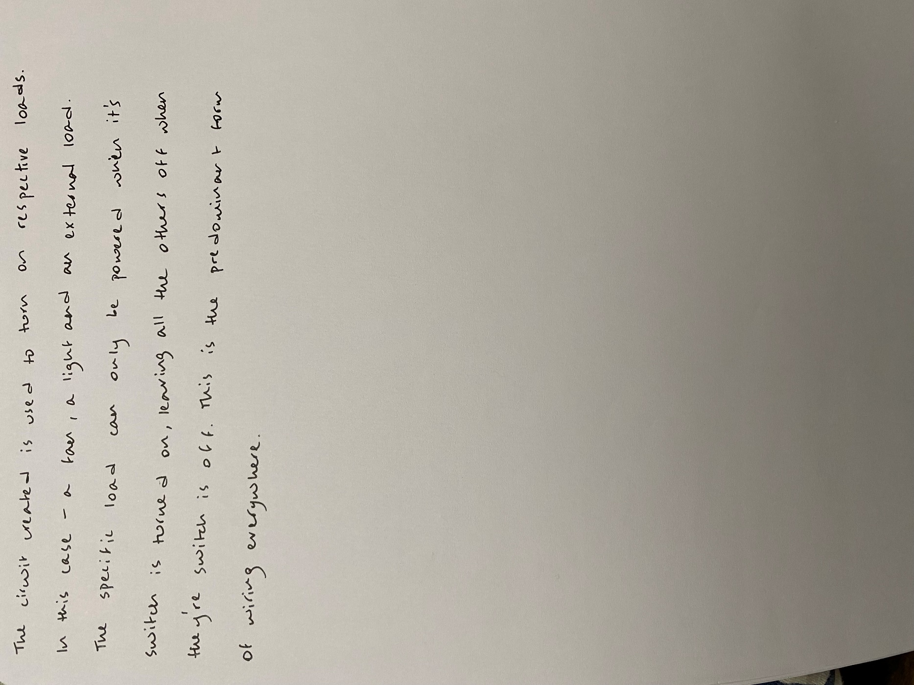

Name of Laboratory : Electrical Workshop

|  |  |
| --- | --- |
| Lab Subject Code | : EEE1003 |
| Name of School | : SELECT |
|  |  |
| **Result** |  |

**Reg. No: 21BDS0340 Name: Abhinav Dinesh Srivatsa Date: 22/11/2021**